# CS 255 System Design Document Template

This template lays out all the different sections that you need to complete for Project Two. Each section has guidance to prompt your thinking. You will need to continually reference the interview transcript as you work to make sure that you are addressing your client’s needs. There is no required length for the final document. Instead the goal is to complete each section based on what your client’s needs are. Remove this note when you are finished, and replace all bracketed text with the relevant information.

## UML Diagrams

### UML Use Case Diagram

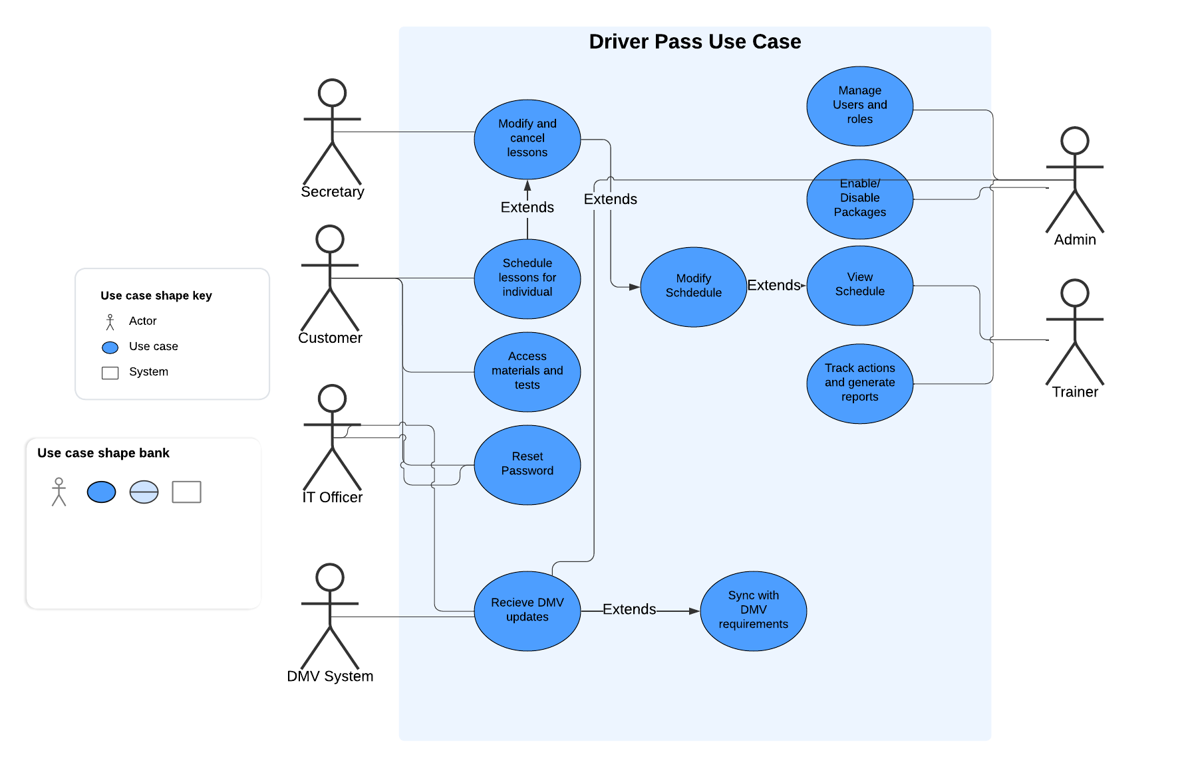

### UML Activity Diagrams

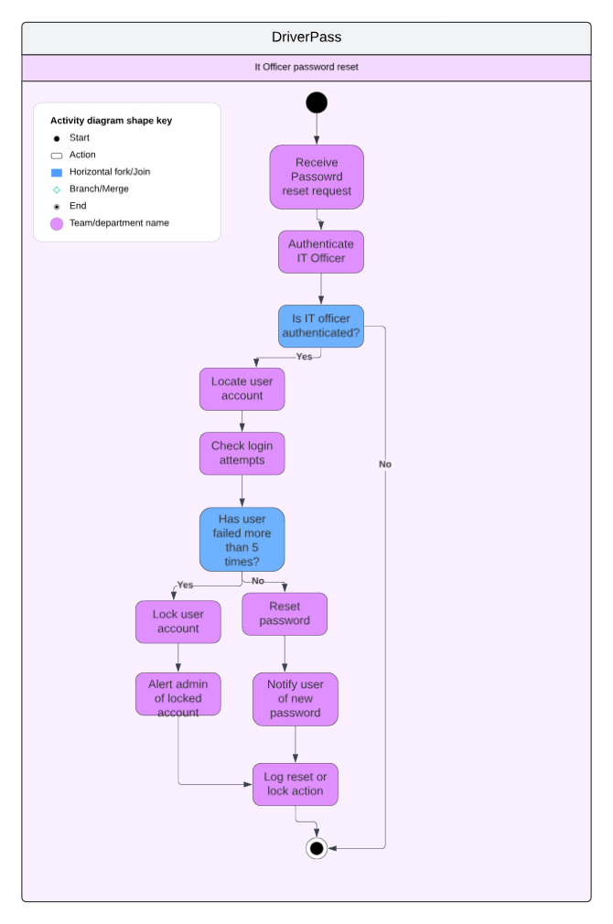

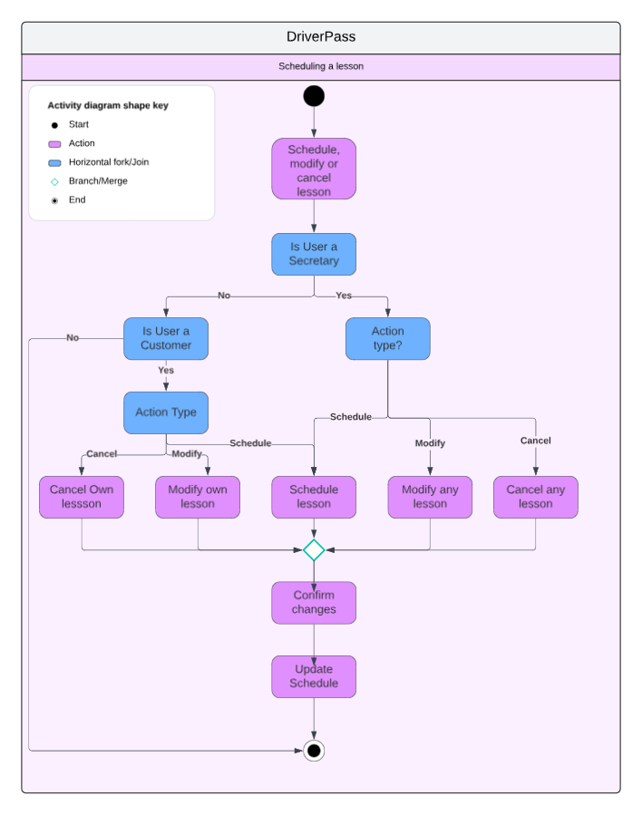

### UML Sequence Diagram

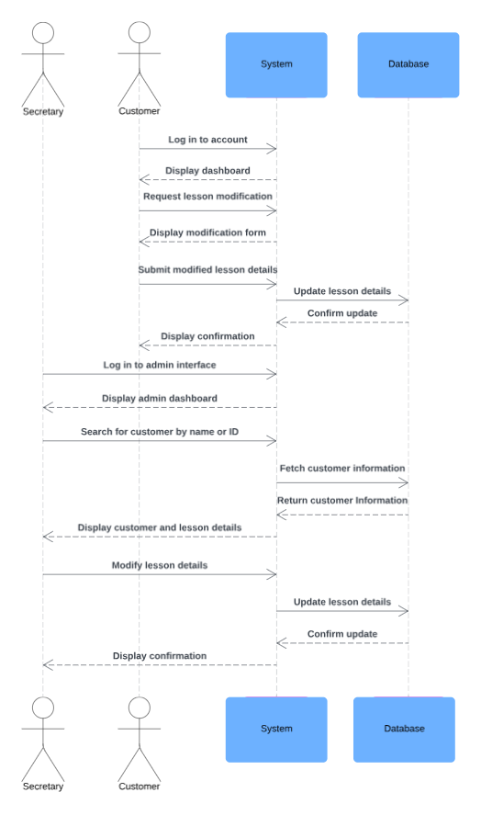

### UML Class Diagram

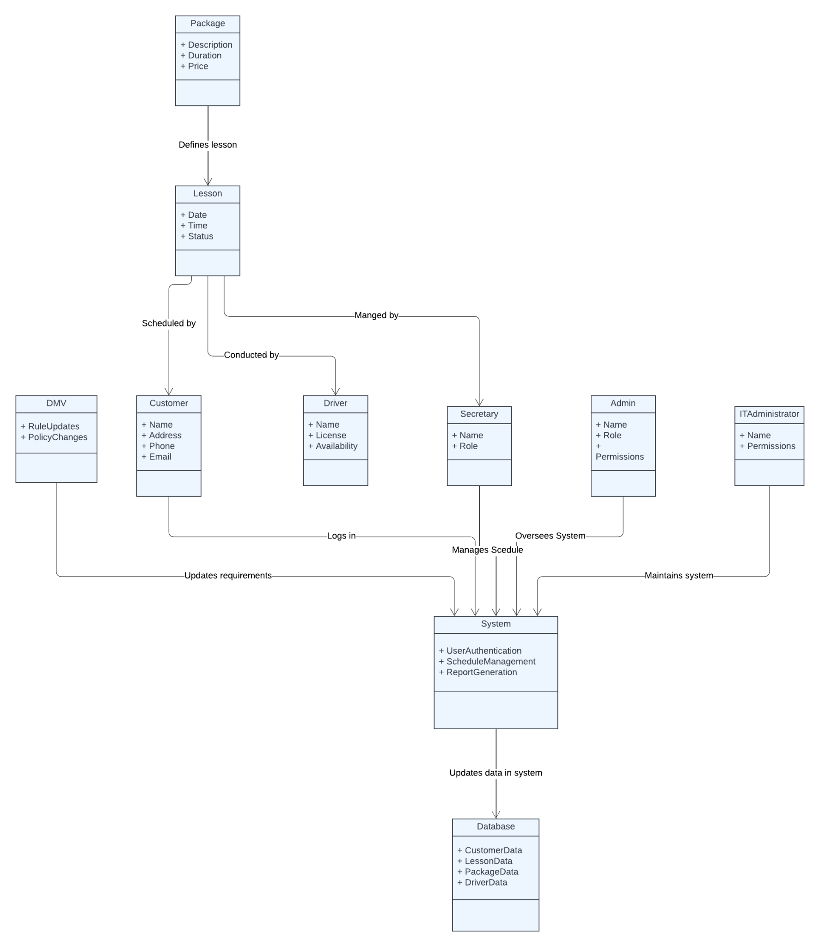

## Technical Requirements

**Hardware requirements:**

Servers - A cloud based server or host will be required to manage the Driverpass system, this will ensure minimal downtime while maintaining good security from outside threats.

The wireless host will require a processor that is capable of handling the expected demand, as well as enough ram and storage to perform operations and store data on the system.

**Software requirements:**

Server - Will require a linux based operating system such as Ubuntu, if system administrators are not familiar with linux a windows operating system can be used but may increase operation costs.

Data storage - Something like MySQL will have to be used to store data such as customers, lessons, tests, packages and staff.

User authentication - The system will have to utilize a secure method to login with their credentials and their role.

User interface - System will have to use something to make an interactive and fast interface for the user to prevent issues.

**Tools:**

Development tools - If the system is made in c++ you can use something like Visual Studio Code, if it is made in python it can be made in Pycharm. While different versions can be backed up on Github to make sure there will always be a working version of the program.

testing tools - You will have to test each version of the program to make sure that it is operational and does not have bugs within the database or user interface.

project management tools - Trello and Jira can help manage the development of the project and future updates. Anyone can view it and it will allow for transparency between what is going.

**Infrastructure requirements:**

Cloud Hosting - Amazon's Azure or Google cloud would be best for hosting the Driverpass System because it would offer flexible packages and as the user base grows demand can be met by upgrading the amount of available processing power.

Load Balancer - Use a load balancer to handle traffic efficiently and effectively throughout the system to prevent bottlenecks and interruptions between users.

Backup and recovery - A system in place to store data and be able to restore to a stable version of the program if needed.

Security - Packet authentication to prevent any outside threats as well as implement a firewall to protect against potential attacks against the system. It is crucial that sensitive data be encrypted to make sure if someone were to get into the system customers private data is secure and not accessible. All changes and actions should be logged on an administrative log to prevent abuse and make sure one is compromised within the system.

**Scalability:**

The system should be flexible and adaptable, as the user base increases it should be able to handle user traffic. DMV updates should occur automatically and update the system Admin of the new changes required for users to pass their test. The administrator should be able to easily add packages or disable packages if needed without a hard system shutdown or restart and should be done through the admin interface without any new code added.